**Physics 30 – Lesson 19**

**Magnetic Fields**

/60

**Part A**

I

S

N

during I flow

N

S

before I flow

A

B

conductor

compass

1)

The Right Hand Rule predicts that the compass needle deflects and points to the **right**.

/2

2)

The Left Hand Rule predicts that the compass needle deflects and points to the **left**.

A

N

S

before e– flow

e–

/2

S

N

B

during e– flow

3)

Using the right hand rule, the fingers curl around the wire and the thumb indicates that the current must be flowing from B to A.

/2

4)

N

Using the right hand rule, the thumb points out of the page and the fingers curl around the wire in a counterclockwise direction. At Point P the magnetic field is pointing down the page.

/2

S

B

A

N

e–

5)

North is left

/2

6)

B

A

S

N

I

South is right

/2

7)

B

A

N

I

current flows from B to A

/2

**Part B**

1)

c)

a)

N

S

N

S

N

/4

d)

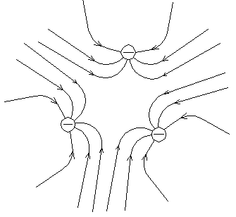

S

S

S

b)

S

S

2)

N

S

before e– flow

The Left Hand Rule predicts that the compass needle deflects **counterclockwise** as seen from above.

e–

/2

S

N

during e– flow

3)

e–

S

N

during e– flow

N

S

before e– flow

The Left Hand Rule predicts that the compass needle deflects **clockwise** as seen from above.

/2

4)

e–

S

N

during e– flow

N

S

before e– flow

The Left Hand Rule predicts that the compass needle deflects **clockwise** as seen from above.

/2

5)

e–

N

S

during e– flow

N

S

before e– flow

The Left Hand Rule predicts that the compass needle deflects **counterclockwise** as seen from above.

/2

6)

X

Receding negatively charged bullet – left hand rule – counterclockwise magnetic field

/2

7)

X

Receding positively charged bullet – right hand rule – clockwise magnetic field

/2

8)

B

A

S

N

Side view

B

A

/2

Counterclockwise electron flow (left hand rule). North pole of magnetic field is at the Bottom of the coil.

9) a) negatively charged disc

N

S

Electrons spinning clockwise will have the same effect as electrons flowing clockwise around a coil. Use the Left Hand Rule and the North Pole generated is up towards you as seen from above.



/2

top view

side view

spinning clockwise

b) positively charge disc

Positive charged spinning clockwise will have the **opposite effect** to that of electrons spinning clockwise. Use the Right Hand Ruleand the North pole generated is down away from you as seen from above.

top view

N

S

/2

10)

S

N

N

North end of compass points in north direction.

North “end” of Earth is a magnetic south pole.

/2

11)

/6

1. at NMP (north magnetic pole)
   * compass will spin freely trying to point down into the Earth
2. at SMP
   * compass will spin freely trying to point up from the Earth
3. at equator
   * compass points north

12) Buildings are constantly being vibrated by winds, cars driving by, people walking inside the building, etc. The resulting vibrations of magnetic domains in the metal line up with the Earth’s magnetic field resulting in the metals become permananet magnets themselves.

/2

13)

N

/2

14)

Sources of fields:

* + electric – charges
  + magnetic – spinning charges, moving charges
  + gravitation – masses

/3

15)

- Ferromagnetic substances are composed of a large number of tiny regions called “magnetic domains.”

- Each domain behaves like a tiny bar magnet.

- When the meterial is not magnetized the domains are randomly aligned so their magnetic effects cancel each other out

- When non-magnefied ferromagnetic material is exposed to a strong magnetic field, the domains turn and align themselves temporarily. The metal acts as a magnet for a short time.

/4

16)

|  |  |  |
| --- | --- | --- |
| **Gravitational** | **Electric** | **Magnetic** |
| -Non polar  -Always attracts  -Masses vector field  -Decreases strength with  distance  -Field lines originate from a mass(es) | -Polar  -Attracts and repels  -Charges vector field  -Decreases strength with  distance  -Field lines originate from a charge(s) | -Bi-polar  -Attracts and repels  -Magnets vector field  -Decreases strength with  distance  -Field lines are closed loops, without beginning or end |



17) Vector fields have a direction, scalar fields do not.



**Station 1 Current-carrying wires** /10 marks

Questions:

1. Does the direction of the magnetic field predicted by the hand rule agree with your observations? Draw a diagram of the magnetic field around a current-carrying wire.

checkmark

Yes, the hand rule agrees with the observed magnetic field direction.

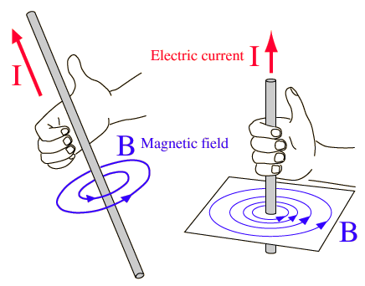

checkmark

* What is the purpose and function of using a compass in this activity?

checkmark

checkmark

The compass acts as a test magnet which indicates the direction of the induced magnetic field around a wire or through a solenoid.

**Station 2 Solenoid – electromagnet**

Questions:

1. Using the appropriate hand rule, does the direction of the magnetic field predicted by the hand rule agree with your observations? Draw a diagram of the magnetic field generated in a solenoid.

checkmark

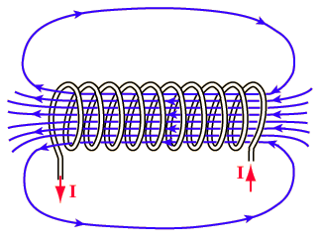The hand rule predicts the observed magnetic field direction.

checkmark

checkmark

1. Compare and contrast an electromagnet and a bar magnet.

checkmark

A bar magnet has a permanent magnetic field which is the result of aligned magnetic domains in the metal.

checkmark

An electromagnet has a field that is induced by current running around a coil of wire.

Both permanent and electro magnets have similar field patterns.

checkmark